Equipment Rental

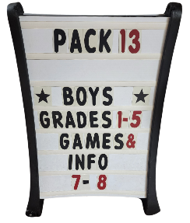

Letter Board

$10 Rental Fee

Inflatable Archery

$25 Rental Fee

Tomahawk/Star Toss

$10 Rental Fee

Connect 4

$10 Rental fee

Unit Type: __________________________________________

Unit Number: _______________________________________

Contact Person Name: ______________________________

Contact Email: ______________________________________

Contact Cell Phone: _________________________________

Date Requested: _____________________________________

Date Pick Up: _______________________________________

Date Return: _________________________________________

Equipment Requested:

1st Choice: _______________________________________

2nd Choice: ______________________________________

3rd Choice: ______________________________________

Due to limited supplies please choose which item you would like, and if that is not available which item you would prefer next.